The Impact of Trump Tariffs on the Federal Budget

**Shiqi Geng**

# Executive Summary

This paper examines the budgetary impact of Trump tariffs from a public finance perspective. Specifically, it investigates to what extent the tariffs introduced by Trump administration on China, Mexico and Canada may achieve the stated policy goal of paying down federal budget deficit. I consider two channels: the direct channel where both static and dynamic scenarios are projected, with the latter considering the demand elasticity of imported goods, and a novel financial channel which examines the impact of tariffs on capital flows.

After analyzing each scenario of tariff policies by Trump administration through both channels, I find that a small increase in tariff is indeed able to close the gap of government deficit to a certain extent, abusing tariff policies (i.e. when tariff rates are too high) can result in reverse effect, which is most prominent when taking into consideration financial channels.

# Motivation

Tariff is introduced by both Trump administrations as means to mitigate trade deficit, which Trump regards as a tax on America that is used to subsidize foreign countries, and even economic rivals, such as China. The result of the “trade tax” is not only an outflow of wealth in face value, but also missing domestic social demand of investment that accompanies, leading to compromised employment outcomes. With all that, Trump administration introduces tariff as a pivotal measure to consolidate wealth domestically, federal budget being a critical beneficiary, and to introduce employment by means of “re-industrialization”.

However, the inflationary response of tariff is ignored. Demand goes down as imported goods get more expensive, compromising social welfare. To put it another way, although the nominal incursion of tariffs is on foreign countries, it is both foreign countries and American people that are actually paying for them.

Another interesting thing to look at lies in the exchange cycle of international trade with the US. A direct result of trade surplus with the US is deposit of US dollars in the vault of foreign central banks that implement control on foreign currencies, such as China. This deposit effectively backs up the issuance of their respective domestic currencies. Therefore, in order to prevent devaluation of their own currencies, foreign central banks tend to exchange their US dollar deposit with T-bills. Conversely, foreign central banks will sell T-bills if there is not as much trade surplus with the US as a result of tariffs, and the yield of T-bills has to go up to make themselves as attractive an investment as before.

All the above motivate the three channels of analysis: the static analysis of direct trade channel reflects the policy setup, the dynamic analysis of trade channel examines the inflationary response and the financial analysis examines the spillover on interest payment of treasury debts.

# Contribution

This paper furthers conventional scoring of policy implications that is currently employed in thinktanks and government agencies, such as the Committee for a Responsible Federal Budget (CRFB) and the Congressional Budget Office (CBO). Moreover, this paper employs the empirical results of past studies and simulations on trade and deficits to create a practical, dynamic analysis. Namely, for each tariff scenario, this paper uses literature results to quantify the demand shock due to tariffs, as well as treasury yield shocks due to change in T-bill supply. With both sets of parameters, a back-of-the-envelope analysis can be conducted with historical data and publicly-available projections.

A great contribution of this paper is that it builds an integrative algorithm that allows for analysis of tariff implications on the federal budget against any trade partner with the United States, and potentially trade activities between any two countries, other than USA.

# Tariff Scenarios

This section discusses possible scenarios for Trump tariff.

1. [25% tariff on Mexico and Canada](https://www.whitehouse.gov/fact-sheets/2025/02/fact-sheet-president-donald-j-trump-imposes-tariffs-on-imports-from-canada-mexico-and-china/)

In early 2025, President Trump announced a 25% tariff on imports from Canada and Mexico, citing national security concerns and issues related to illegal immigration and drug trafficking. Initially set to take effect on February 4, these tariffs were delayed by one month following negotiations. On March 4, the tariffs were implemented, with Canadian energy resources facing a reduced 10% tariff. Subsequently, on March 7, the U.S. adjusted its stance, largely reversing the 25% tariffs but maintaining a 10% tariff on certain imports to minimize disruptions, particularly in the automotive industry. (The White House, 2025)

1. [10% and 60% tariff on China](https://www.yahoo.com/news/trump-throws-tiktok-lifeline-yet-064251451.html?guccounter=1&guce_referrer=aHR0cHM6Ly93d3cuZ29vZ2xlLmNvbS8&guce_referrer_sig=AQAAAL_fKDZzqCXtgmmn6PF7a0f5vwZB-dbLHHWklfR3EH7WymTtEj8n04sckc4hrL0AIe8TNSTkvKROGTh6uzea6H9Th4Yseg4I2ZQa7wl0eNIfG2xjwRBKGnxif1Dcs62AL6AWbsu_niySyTgnBl7K4vfPgncZcYxLgwsOqXQnr363)

On February 1, President Trump signed Executive Order 14195, imposing a 10% tariff on all Chinese imports, effective February 4. Later, on February 27, Trump announced an additional 10% tariff, effective March 4, citing insufficient progress in curbing fentanyl inflows. (The White House, 2025)

As early as last year, then republican candidate Trump proposed a 60% tariff on China. (CRFB, 2024)

## Data

US import data was gathered from UN Comtrade online database at 5-digit Harmonized System (HS) code level. The duty rate of each commodity from each of the countries is obtained from WTO Tariff Analysis Online (TAO)

## Two Channels of the Analysis

1. Analysis of trade flow implications

This paper first examines the income increase due to tariff without considering change in import quantity. A net increase in federal income is expected in this scenario. A dynamic analysis taking into consideration the reduction of import quantity is also conducted.

1. Analysis of financial dynamics

This channel assumes there is a one-on-one relationship between changes in T-bill supply and change in trade deficit. Analysis of reduction in trade deficit is conducted based on dynamic trade flow analysis of previous section. At the end of the day, change in interest payment can be calculated.

# Results

1. 25% tariff on Mexico and Canada

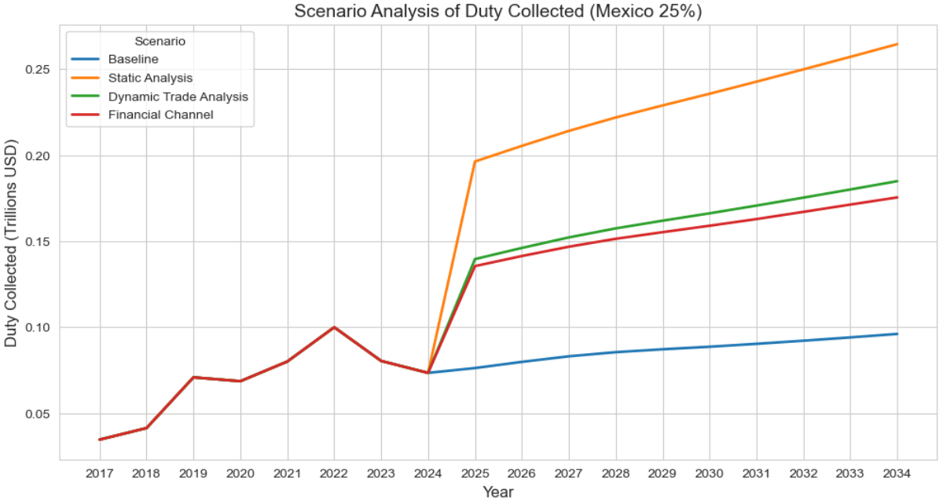

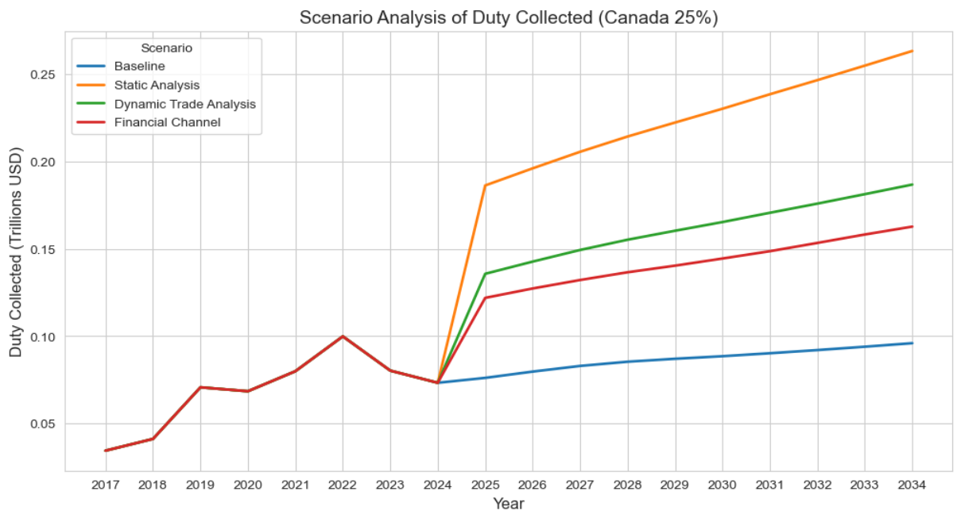

25% tariff on Canada and Mexico can overall increase collected duty, filling the gap of deficit. As expected, duty collected decreases with more dynamic factors taking into consideration (decrease in demand and financial channel).

1. 10% and 60% tariffs on China

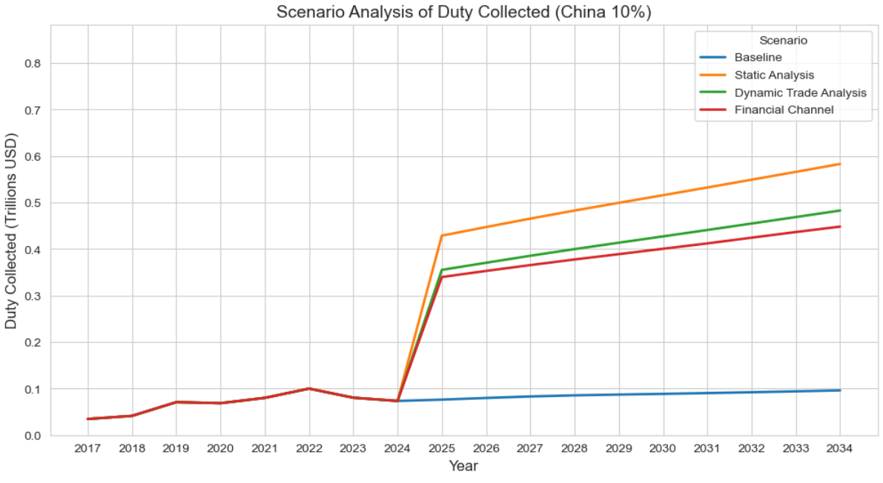

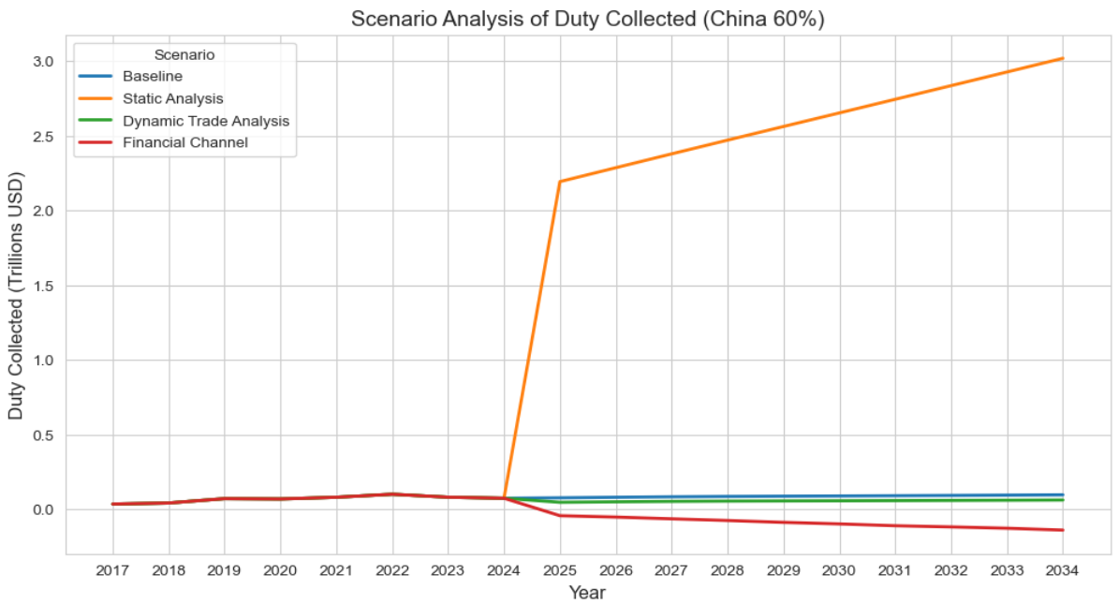

As shown in the case of Canada and Mexico, 10% tariff on China can increase duty collected. However, 60% tariff on China will lose money under the two dynamic channels.

# Policy Implication

The result implies that a moderate tariff will increase duty collected and potentially achieve the stated purposes of the tariffs in tacking deficit problems. However, when the tariff is too high, it might deteriorate the problems. Note that the conclusion is drawn without taking into consideration retaliation scenarios or analysis of the social and economic impact of inflation.

References

CRFB. (2024, April 10). *Donald Trump’s 60% Tariff on Chinese Imports-2024-04-10*. https://www.crfb.org/blogs/donald-trumps-60-tariff-chinese-imports

The White House. (2025, February 13). *Fact Sheet: President Donald J. Trump Announces “Fair and Reciprocal Plan” on Trade*. The White House. https://www.whitehouse.gov/fact-sheets/2025/02/fact-sheet-president-donald-j-trump-announces-fair-and-reciprocal-plan-on-trade/